Suppose we have a file system that stores both files and directories. An example of one system is represented in the following picture:

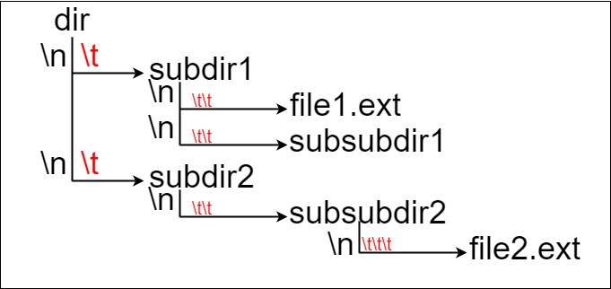

Here, we have dir as the only directory in the root. dir contains two subdirectories, subdir1 and subdir2. subdir1 contains a file file1.ext and subdirectory subsubdir1. subdir2 contains a subdirectory subsubdir2, which contains a file file2.ext.

In text form, it looks like this (with ⟶ representing the tab character):

dir  
⟶ subdir1  
⟶ ⟶ file1.ext  
⟶ ⟶ subsubdir1  
⟶ subdir2  
⟶ ⟶ subsubdir2  
⟶ ⟶ ⟶ file2.ext

If we were to write this representation in code, it will look like this: "dir\n\tsubdir1\n\t\tfile1.ext\n\t\tsubsubdir1\n\tsubdir2\n\t\tsubsubdir2\n\t\t\tfile2.ext". Note that the '\n' and '\t' are the new-line and tab characters.

Every file and directory has a unique **absolute path** in the file system, which is the order of directories that must be opened to reach the file/directory itself, all concatenated by '/'s. Using the above example, the **absolute path** to file2.ext is "dir/subdir2/subsubdir2/file2.ext". Each directory name consists of letters, digits, and/or spaces. Each file name is of the form name.extension, where name and extension consist of letters, digits, and/or spaces.

Given a string input representing the file system in the explained format, return *the length of the* ***longest absolute path*** *to a* ***file*** *in the abstracted file system*. If there is no file in the system, return 0.

**Note** that the testcases are generated such that the file system is valid and no file or directory name has length 0.

**Example 1:**

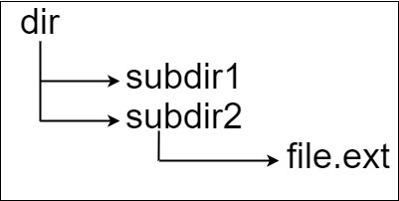

Input: input = "dir\n\tsubdir1\n\tsubdir2\n\t\tfile.ext"  
Output: 20  
Explanation: We have only one file, and the absolute path is "dir/subdir2/file.ext" of length 20.

**Example 2:**

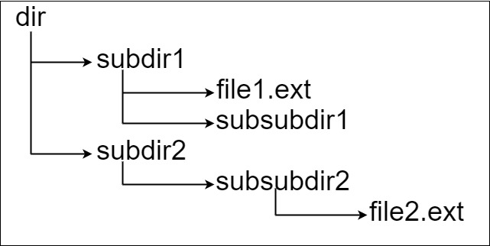

Input: input = "dir\n\tsubdir1\n\t\tfile1.ext\n\t\tsubsubdir1\n\tsubdir2\n\t\tsubsubdir2\n\t\t\tfile2.ext"  
Output: 32  
Explanation: We have two files:  
"dir/subdir1/file1.ext" of length 21  
"dir/subdir2/subsubdir2/file2.ext" of length 32.  
We return 32 since it is the longest absolute path to a file.

**Example 3:**

Input: input = "a"  
Output: 0  
Explanation: We do not have any files, just a single directory named "a".

**Constraints:**

* 1 <= input.length <= 104
* input may contain lowercase or uppercase English letters, a new line character '\n', a tab character '\t', a dot '.', a space ' ', and digits.
* All file and directory names have **positive** length.